Occurrence records for ecological niche modeling:



* [](https://www.google.com/url?sa=i&rct=j&q=&esrc=s&source=images&cd=&ved=2ahUKEwjYmZvr3-TjAhUKRKwKHaTNBNsQjRx6BAgBEAU&url=https%3A%2F%2Fholos.berkeley.edu%2Fabout%2Fdata-discovery%2Fvertnet%2F&psig=AOvVaw3M5Efuanq264MIt0qyq4xZ&ust=1564854606267702)GBIF (<https://www.gbif.org/en/> ): global database that comprises many of the following
* VertNet (<http://vertnet.org/>): vertebrates (mammals, reptiles, amphibians, birds, fish):



* SCAN (<https://scan-bugs.org/portal/Invertebrates/> ): invertebrates (insects, arachnids):

[](https://www.google.com/url?sa=i&rct=j&q=&esrc=s&source=images&cd=&ved=2ahUKEwjBp4m_3-TjAhVCX60KHdELBfEQjRx6BAgBEAU&url=https%3A%2F%2Finaturalist.nz%2Fpages%2Fmobile_apps_nz&psig=AOvVaw0upYTngI1R2ANQGAgZLJMo&ust=1564854515053071)

* iNaturalist (<https://www.inaturalist.org/> ): literally everything

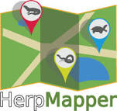

* HerpMapper (<https://www.herpmapper.org/> ): reptiles and amphibians
* [](http://www.naherp.com/)NAHerp (<http://www.naherp.com/> ): reptiles and amphibians

[Home](https://www.tropicos.org/Home.aspx)

* Tropicos (<https://www.tropicos.org/Home.aspx> ): plants
* eBird (<https://ebird.org/home> ): birds

Ecological Niche Modeling with Maxent:

Maxent Website: <http://biodiversityinformatics.amnh.org/open_source/maxent/>

Maxent tutorial: <http://www.amnh.org/content/download/141371/2285439/file/LinC3_SpeciesDistModeling_Ex.pdf>

[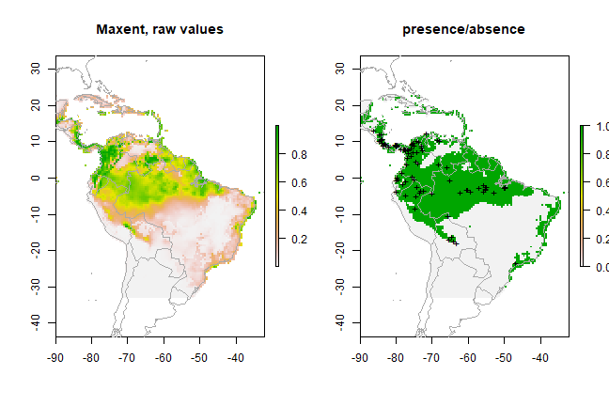](https://www.google.com/url?sa=i&rct=j&q=&esrc=s&source=images&cd=&ved=2ahUKEwjGrMC68uTjAhVKQq0KHaAgAKAQjRx6BAgBEAU&url=https%3A%2F%2Frspatial.org%2Fsdm%2F6_sdm_methods.html&psig=AOvVaw0W7gBaFopia2-ueV2IMUaB&ust=1564859604090615)Maxent Google Groups: <https://groups.google.com/forum/#!forum/MAXENT>

* browse and post questions about Maxent and associated R packages (ENMeval, dismo, ENMtools)

**R packages for niche modeling:**

*ENMeval*: model testing and building ENMs using Maxent

Muscarella R, Galante PJ, Soley‐Guardia M, Boria RA, Kass JM, Uriarte M, Anderson RP. ENM eval: An R package for conducting spatially independent evaluations and estimating optimal model complexity for Maxent ecological niche models. Methods in Ecology and Evolution. 2014 Nov;5(11):1198-205.

*dismo*: builts ENMs using Maxent, can project on different climate scenarios

Hijmans RJ, Phillips S, Leathwick J, Elith J. dismo: Species distribution modeling. R package version 0.8-17. 2013.

*kuenm*: model testing and building ENMs

Cobos ME, Peterson AT, Barve N, Osorio-Olvera L. kuenm: an R package for detailed development of ecological niche models using Maxent. PeerJ. 2019 Feb 6;7:e6281.

*ENMtools*: various niche assessments, including tests of niche similarity among species

Warren DL, Glor RE, Turelli M. ENMTools: a toolbox for comparative studies of environmental niche models. Ecography. 2010 Jun;33(3):607-11.

*ecospat*

Di Cola V, Broennimann O, Petitpierre B, Breiner FT, D'amen M, Randin C, Engler R, Pottier J, Pio D, Dubuis A, Pellissier L. ecospat: an R package to support spatial analyses and modeling of species niches and distributions. Ecography. 2017 Jun;40(6):774-87.

**Other useful R packages**

*spThin*: thins occurrence records

Aiello‐Lammens ME, Boria RA, Radosavljevic A, Vilela B, Anderson RP. spThin: an R package for spatial thinning of species occurrence records for use in ecological niche models. Ecography. 2015 May;38(5):541-5.

*raster, maptools*: mapping of spatial data

*General tip*: some environmental variables are easy to download and process (e.g. Worldclim), some are not. Learning how to process complex variables in weird formats (e.g., SSURGO) is a skill on its own. If you want to use these variables, you might want to seek a GIS expert for help.

Environmental Variables for ecological niche modeling:

Below are a few examples, we are also providing a more complete list

**WorldClim** (<https://www.worldclim.org/>): current, past, future climatic variables:

* these are the easiest to download and work smoothly with Maxent

**PRISM** (<http://www.prism.oregonstate.edu/>): current, past, future climatic variables:

* these are also easy to download and should work smoothly with Maxent

**VARIOUS ENVIRONMENTAL VARIABLES** (<https://gdg.sc.egov.usda.gov/GDGHome_DirectDownLoad.aspx>):

**SSURGO (**<https://nrcs.app.box.com/v/soils>**)**: various soil-related variable

* you need to be pretty skilled with GIS to get and process these layers in a way that will make them useful for ENMs. I suggest you seek a GIS expert to help you.
* various variables in one convenient place via USDA website

**LANDFIRE** (<https://landfire.gov/>)